Docker images push to docker hub from vagrant ;

First we need to check images working or not then we push dockerfile, to the docker hub,
Open the vagrant go access to the dockerfile,
Now we start to the push the dockerfile in docker hub, open to the docker hub,

Open git [vagrant]
Sudo docker image,
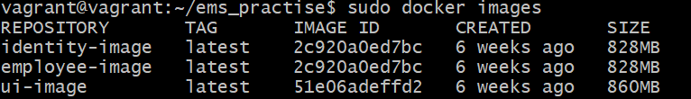

Tag image ;
Sudo docker tag employee-image:lastest yatheesh836/ems:e-i
Now I Explain to the tag command,
Employee-image === this is our docker image name.
Yatheesh836===== this is our docker hub username.
Ems==== this is our docker repository name.
e-i==== this is our choices [hear you will give any name no probleam]

logged in to Docker Hub using the correct credentials,
sudo docker login -u yatheesh836

password ;

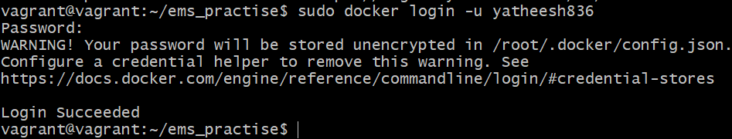

After tagging the image, you can push it to Docker Hub using the docker push command:
sudo docker push yatheesh836/ems:e-i

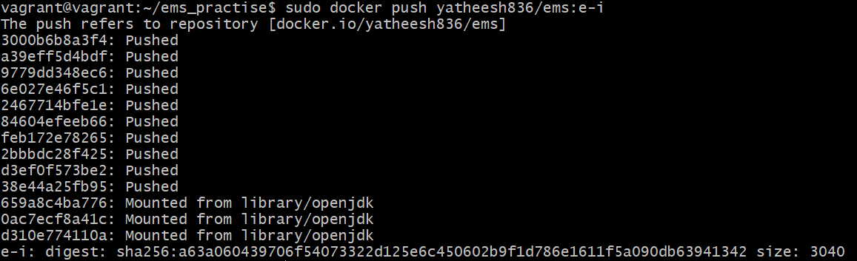

Next check the docker hub, open the repository here shows the image,
Clicken on this tags option,

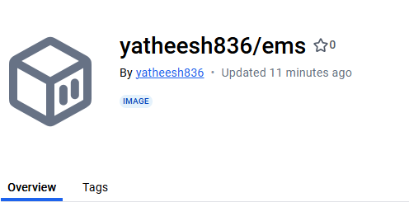
Here shows like this our images,

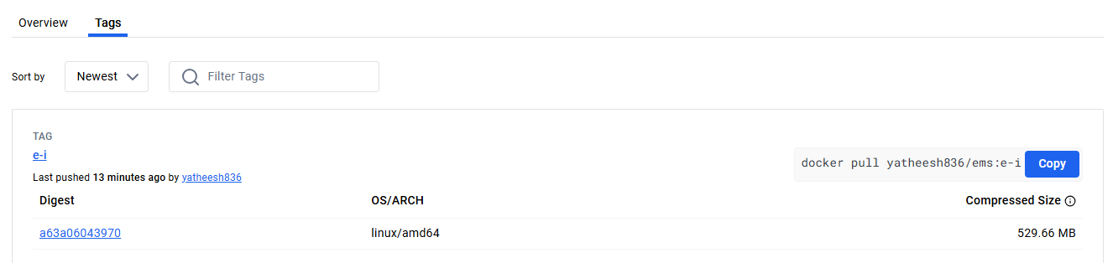

Do like this ui and identity modiles ;
identity ;
sudo docker tag identity-image:latest yatheesh836/ems:identity-i

Sudo docker login -u yatheesh836
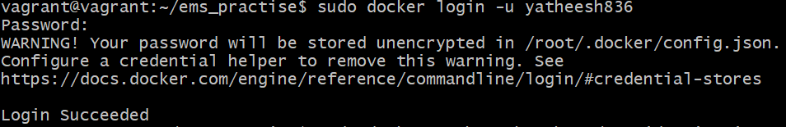
push docker hub,
sudo docker push yatheesh836/ems:identity-i
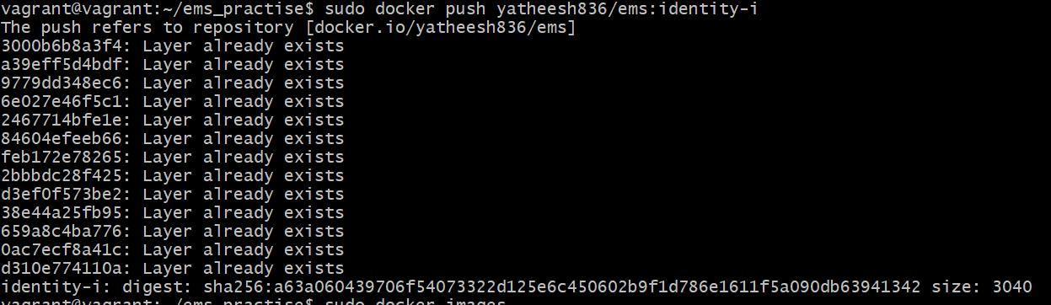

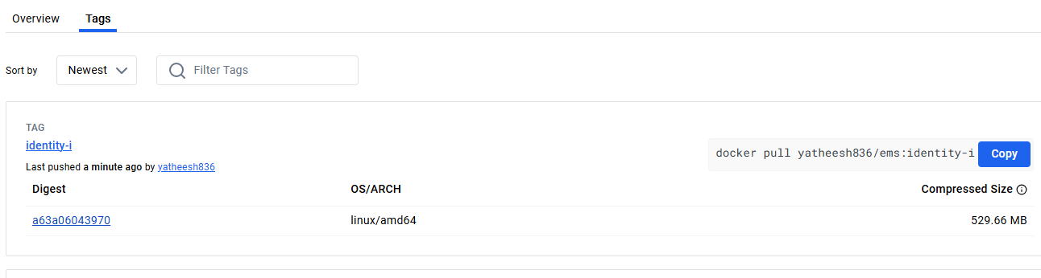

Ui ;
Tag
Sudo docker tag ui-image:latest yatheesh836/ems:ui-i
Sudo docker push yatheesh836/ems:ui-i
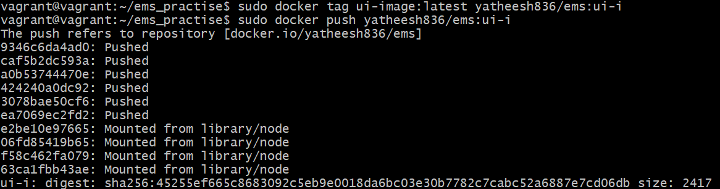



All images ;
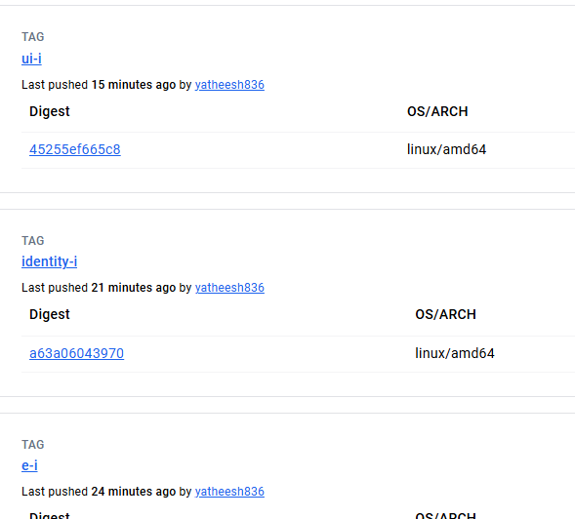

#=====================#================0==============#==========================#

